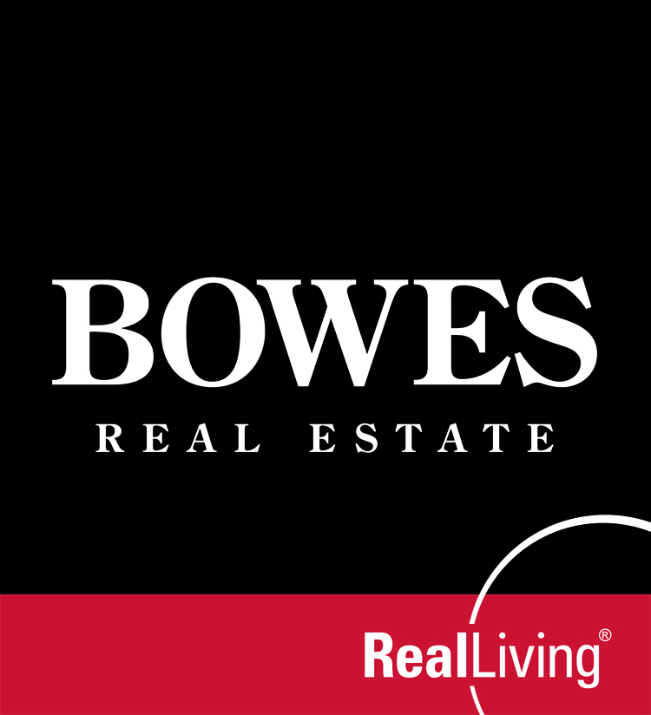

Exclusive Buyer Representation Agreement

Name: ______________________________________________________________ (“Buyer”),
Address: ______________________________________________________________

retains Bowes Corporation, doing business as Bowes Real Estate Real Living (referred to as “BOWES”) to locate real property acceptable to Buyer, subject to the conditions as provided in this Agreement. The Buyer and BOWES agree as follows:

1. PURPOSE: Buyer is retaining BOWES to represent Buyer in acquiring real property through purchase, lease, acquisition or exchange (all or any of which is referred to as an “Acquisition”). Buyer retains the sole and absolute right to determine if a property is acceptable.

2. TERM: This Agreement shall be in effect from _________________________________________or to completion of the Acquisition of the property, if under agreement, whichever is later (the “Term”).

- BOWES AGREES TO:

- Use reasonable efforts to locate a property acceptable to Buyer through the Multiple Listing Service.
- Work in the Buyer’s best interest and perform the fiduciary duties owed by an agent, including: obedience to lawful directions, loyalty, disclosure of material information, confidentiality, accountability and reasonable care, except to the extent modified in the event of Disclosed Dual Agency (see below).
- Assist Buyer with other aspects of the transaction, including coordination of inspections, securing a mortgage and other relevant services.
- Refrain from disclosing financial information about Buyer to the Seller or Seller’s agent, except as reasonably required to establish Buyer’s financial qualification.
- Provide a Comparative Market Analysis on property Buyer wishes to acquire.
- Provide a Due Diligence checklist for the property Buyer wishes to acquire service.

4. BUYER AGREES TO:
- Work exclusively with BOWES during the Term and conduct all negotiations for Acquisitions through BOWES (Buyer represents that Buyer is not bound by any agreement, such as, a buyer representation agreement with another broker, the provisions of which are inconsistent with the provisions of this Agreement).
- Cooperate with BOWES in providing personal information necessary to evaluate Buyer’s needs and qualifications and in scheduling appointments for showings.
- Provide BOWES with a pre-approval letter, within 7 days of the execution of this Agreement.
- Consult with BOWES: (i) before visiting open houses (and advise listing brokers/sales agents at open houses of the buyer-client relationship with BOWES); (ii) before contacting or responding to other brokers or their sales agents (and advise all brokers or their sales agents of the buyer-client relationship with BOWES); and (iii) before contacting or responding to sellers of properties, whether or not those sellers are represented by a broker.

5. DUAL AGENCY:

The Buyer understands the firm’s policy regarding agency relationships and understands that BOWES and its’ affiliated agents represent both prospective purchasers and sellers of real estate. Therefore there may be instances when you will want the BOWES’ sales agent who is representing you to show you properties that are listed with BOWES. When an agent or agents affiliated with BOWES represents a buyer and a seller in the same transaction, Dual Agency is created. A real estate broker or salesperson may act as an agent for both a seller and a buyer of real estate with the informed written consent from both the seller and the buyer. The Dual Agent(s) assists the seller and the buyer in the transaction but shall be neutral with regard to conflicting interest of the seller and the buyer. Consequently, a dual agent will not have the ability to satisfy fully the duties of loyalty, full disclosure, reasonable care and obedience to lawful instructions, but shall owe the duty of confidentiality of material information and the duty to account for funds.

Material information received from either client that is confidential may not be disclosed by a dual agent, except: (1) if disclosure is expressly authorized; (2) if such disclosure is required is required by law; (3) if such disclosure is intended to prevent illegal conduct; or (4) if such disclosure is necessary to prosecute a claim against a person represented or to defend a claim against the broker or salesperson. The duty of confidentiality shall continue after the termination of the brokerage relationship. In signing this Agreement, the Buyer hereby gives informed consent to Consensual Disclosed Dual Agency. In the event Dual Agency occurs, Bowes shall give written notice to the both the Seller and the Buyer.

6. COMPENSATION:

If during the Term of this agreement, Buyer executes an agreement (in whatever form) with a Seller for an Acquisition, the parties agree that Broker shall accept compensation from the listing company, or from the transaction. If the Buyer elects to purchase a property that does not provide buyer agent compensation, most likely, but not always, a “For Sale by Owner”, Buyer will be obligated to pay BOWES a fee of not more than 2.5% of the purchase price. Every effort will be made to include the fee as part of the transaction. Such fee is paid only, if as and when the closing occurs. Buyer will always be made aware of this potential, prior to viewing the property. The provisions of this Agreement concerning compensation to be paid to BOWES shall survive the termination of this Agreement. No fee however will be due the Broker if the Buyer enters into a subsequent written agreement after termination of this Agreement with another licensed broker that obligates them to pay a fee.

7. DISCLAIMER:

Buyer acknowledges that BOWES may represent other buyers who are interested in the same or similar properties. In order to preserve each buyer’s confidentiality in the event there are other offers from buyers within BOWES, seeking to acquire the same property, the sales agent may not disclose material confidential information received from prospective buyers to any other prospective buyers.
BOWES is being retained solely as a real estate broker and not as an attorney, lender, appraiser, surveyor, structural engineer, home inspector or other professional service provider. Buyer is advised by BOWES to seek professional advice from qualified service providers to answer questions Buyer may have relative to a proposed transaction. Buyer agrees that BOWES and its sales agents shall not be liable for disclosing to Buyer any information received from a seller, listing agent, municipality or other source, which is inaccurate, unless BOWES had actual knowledge that the information was inaccurate when it made the disclosure.

8. EQUAL OPPORTUNITY: The parties hereto agree to abide by all applicable fair-housing laws.

9. MODIFICATION OF THIS AGREEMENT: Any modification of this Agreement must be in writing, signed and dated by all parties. This Agreement constitutes the entire agreement between the parties. Any prior agreements, whether oral or written, have been merged and incorporated into this Agreement.

10. MASSACHUSETTS SEX OFFENDER REGISTRY
If the Buyer is concerned about the possible presence of a registered sex offender they may check the Massachusetts state sex offender registry at or by contacting the local police. Buyer acknowledges that neither the Seller nor the Broker is responsible for the accuracy of the information therein provided.

11. OTHER PROVISIONS: ________________________________________________________________________________________________________________________________________________________________________________________________________________________
Buyer acknowledges BOWES’ advice to seek legal counsel relating to any provision of this Agreement if not understood and acknowledges receipt of (a) a copy of this Agreement, (b) a copy of the Massachusetts Mandatory Licensee-Consumer Relationship Disclosure Form, and (c) a brochure entitled “Home Inspector Facts For Consumers.”
BOWES Real Estate Real Living

Buyer: _________________________________ By: __________________________________________ Date: _____________
Sales Agent
Buyer: _________________________________

